**ABSTRACT SUBMISSION GUIDELINES FOR ICMST2024**

First Author1,2, Second Author2, Third Author2 and Last Author 1,2

1 Department, University / Institute, City, Taiwan.

2 Department, University / Institute, City, Taiwan.

Email:

**INTRODUCTION**

This document outlines the guidelines for abstract submission for ICMST2024. Please follow this template to format your abstract. Submit all abstracts through the conference's abstract submission system on the website by July 31, 2024. Abstracts should be in PDF format, no larger than 8 MB. Notification of acceptance will be sent by August 30, 2024. Abstracts not conforming to this template may be rejected. The manuscript should include sections titled INTRODUCTION, METHODS, RESULTS AND DISCUSSION, and CONCLUSIONS, formatted with justified alignment and no paragraph indentations.

**METHODS**

Prepare your abstract on a single A4 page (210 x 297 mm) with two columns of justified text. Margins should be set at 20 mm top, and 15 mm left, right, and bottom. Use Times New Roman 11 pt for text and 9 pt for figure/table captions. The title should be in bold and caps, centered along with authors and affiliations marked with numerical superscripts for different institutions. Include the corresponding author's email. Authors must have significantly contributed to the study's design, data analysis, manuscript drafting, and final approval.

**RESULTS AND DISCUSSION**

Include up to one figure and one table within the document; place these immediately following relevant text and refer to them in parentheses (Figure 1). Position table captions above the table and figure captions below. Tables spanning two columns should be placed at the bottom of the page. References should be cited in the text using square brackets [1,2] and listed at the end of the document.

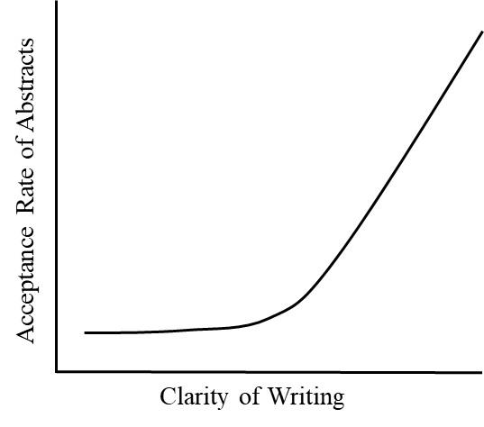

**Figure 1**Acceptance rate of abstracts as a function of clarity of writing.

**CONCLUSIONS**

Summarize the main findings and discuss their relevance to the broader field. Use clear, straightforward English and base conclusions directly on the presented data. Direct all conference inquiries toicmst2024＠tsmst.org.

**ACKNOWLEDGEMENTS**

Acknowledge funding sources and other resources, citing the organization and reference numbers (If applicable).

**REFERENCES**

[1] Lu TW et al. *Gait Posture* **27**: 309-315, 2008.

[2] Wu KW et al. *Gait Posture* **90**: 313-319, 2021.

**Table 1:** Tables that extend across both columns should be placed at the bottom of the abstract.

|  |  |  |  |  |
| --- | --- | --- | --- | --- |
|  | Group A | Group B | Effect size | *p-value* |
| Variable 1 (Units) | 3.1 ± 0.6 | 2.4 ± 0.7 | 0.76 | *p* = 0.012 |
| Variable 2 (Units) | 19.2 ± 4.2 | 15.5 ± 2.5 | 1.18 | *p* = 0.001 |